Foldable magnetic black card gift box
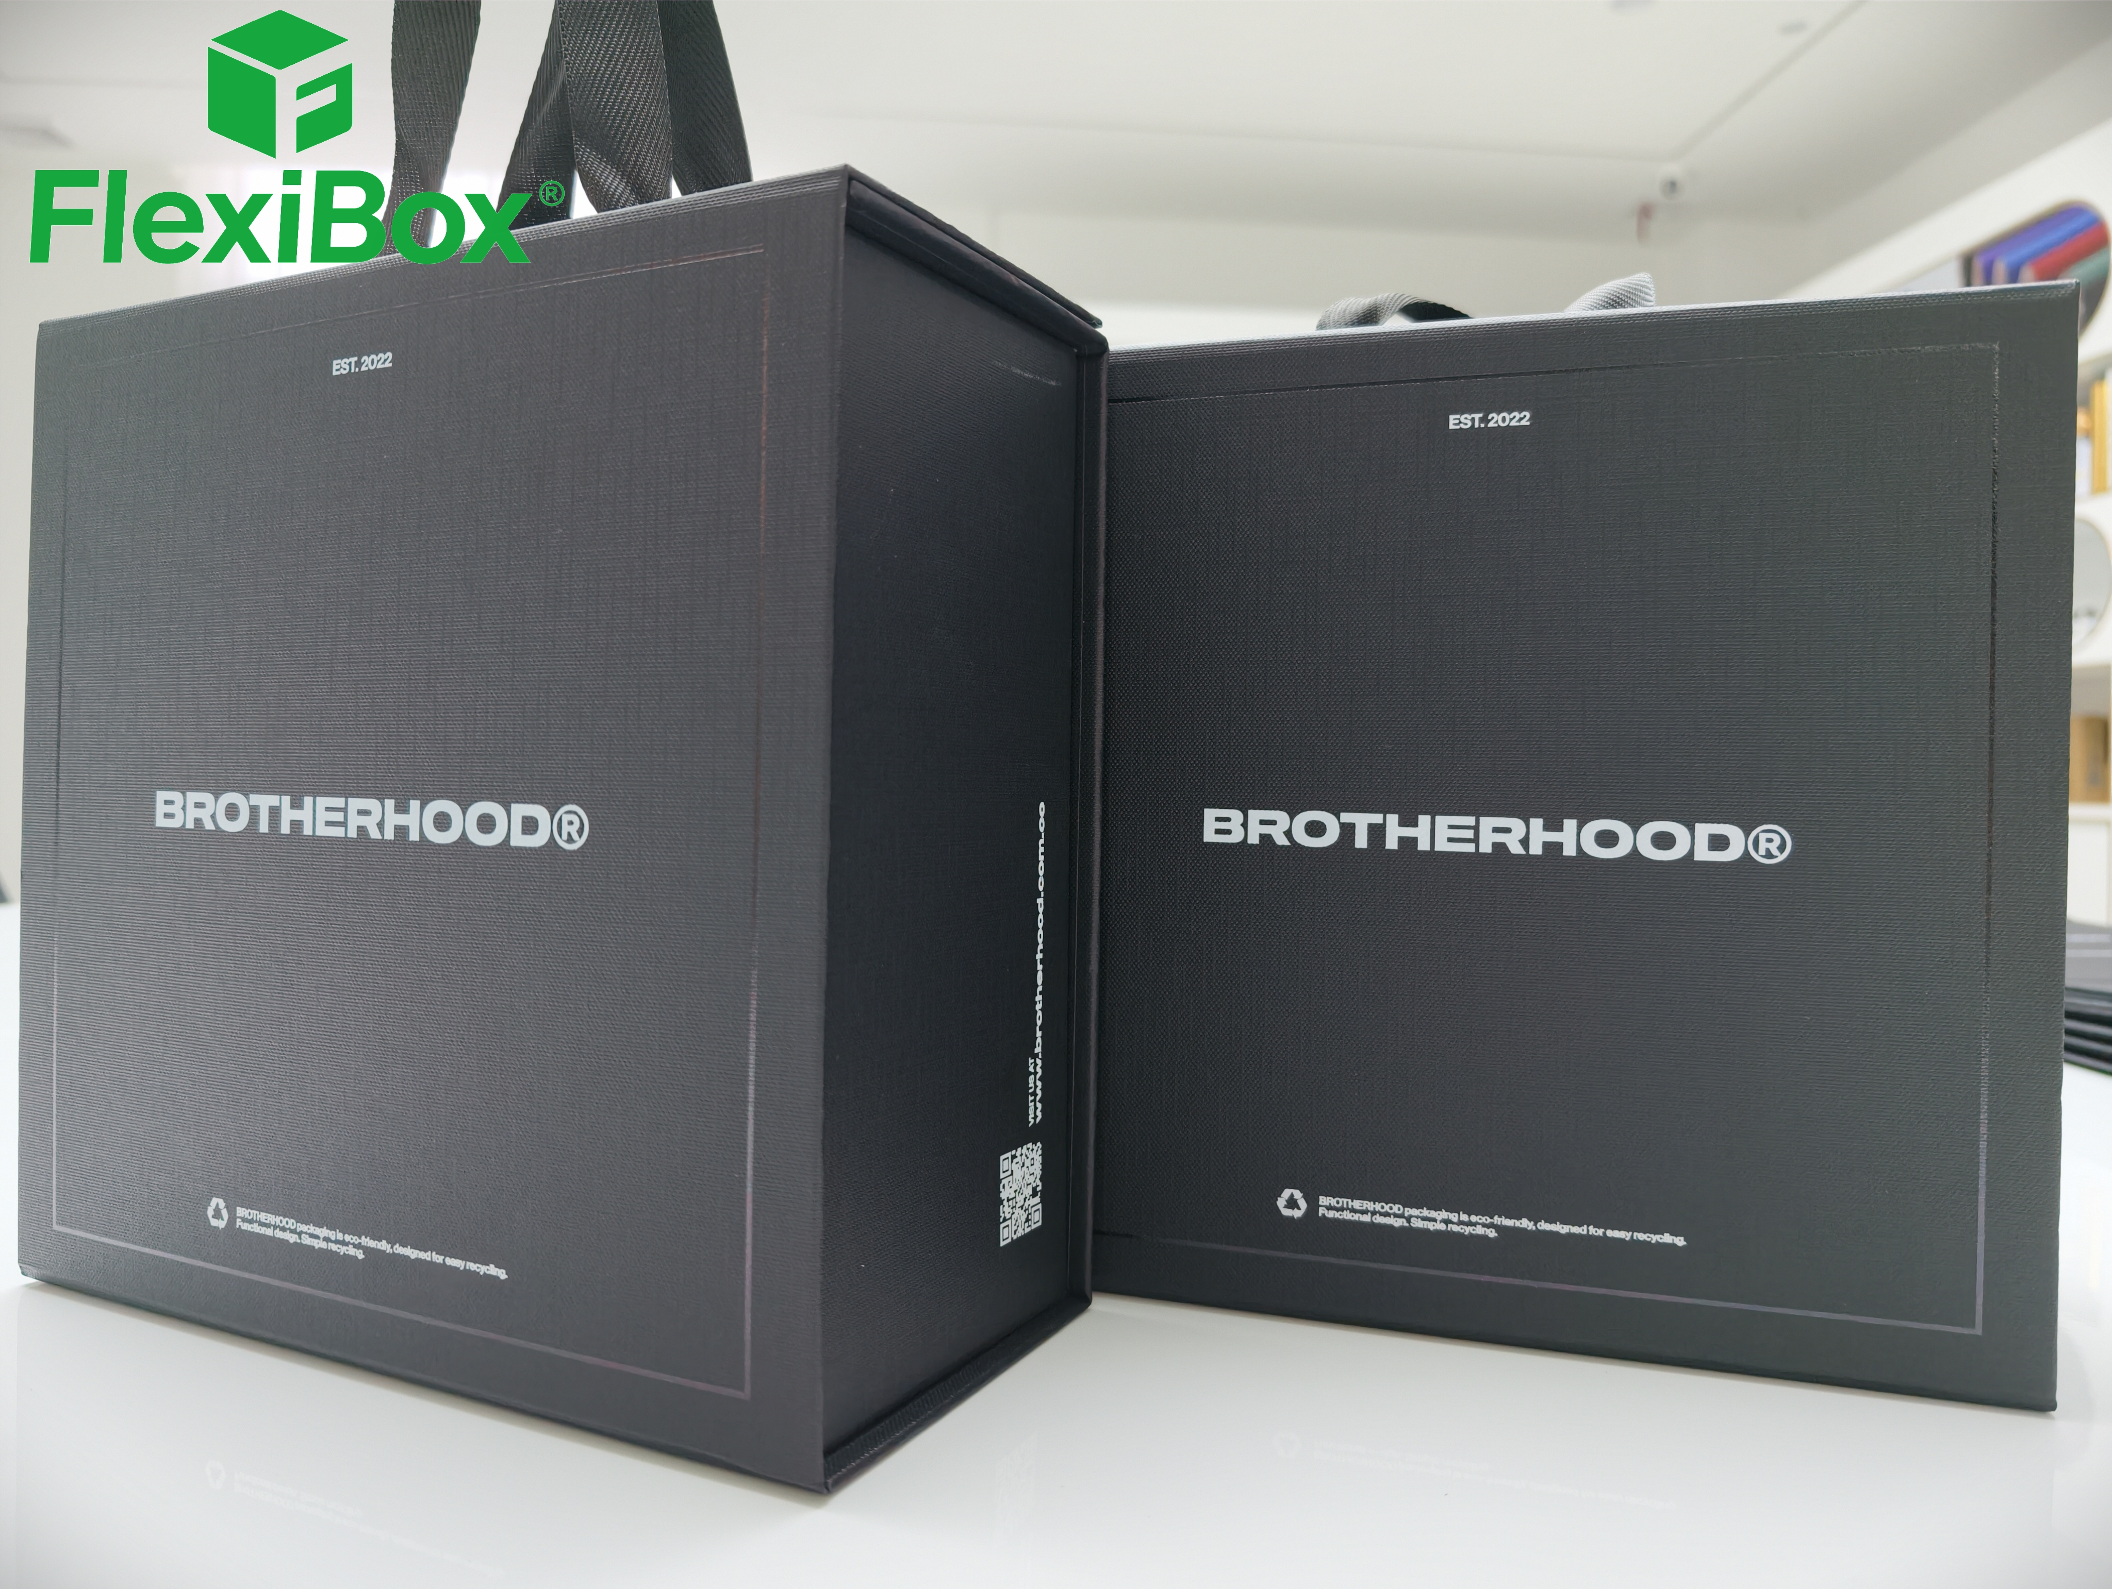
I. Applicable Industries & Uses
Hat packaging boxes, clothing and hat gift sets, trendy apparel gift boxes, luxury clothing gift boxes, scarf boxes, Latin American tourist souvenir packaging boxes; This is a stylish South American Latin trendy clothing and hat packaging box, perfectly matching the American avant-garde minimalist dark style.

II. Core Advantages of the Box
Foldable magnetic one-piece molding gift box, saving on warehousing and logistics costs. Special paper carrying box.
The folded volume is only about 15% of the molded volume.

The empty box can be completely flattened for shipping, reducing warehousing space by more than 85%.

Significantly reduces sea and air freight logistics costs, saving costs and increasing efficiency for global brand customers.

Magnetic flip-top molding is fast, providing end users with a complete unboxing experience; no glue assembly required, environmentally friendly and easily recyclable.

Pain Points Addressed: Traditional hard boxes have high transportation costs and large inventory space; ordinary folding boxes lack magnetic closure and have a cheap feel.
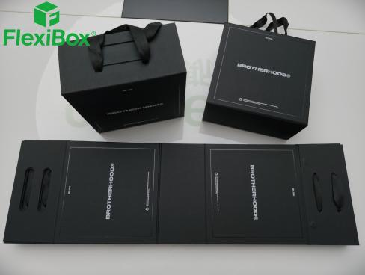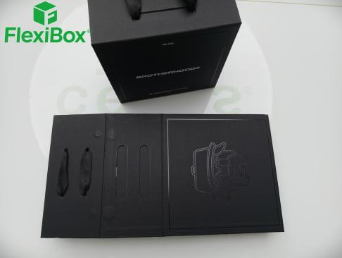
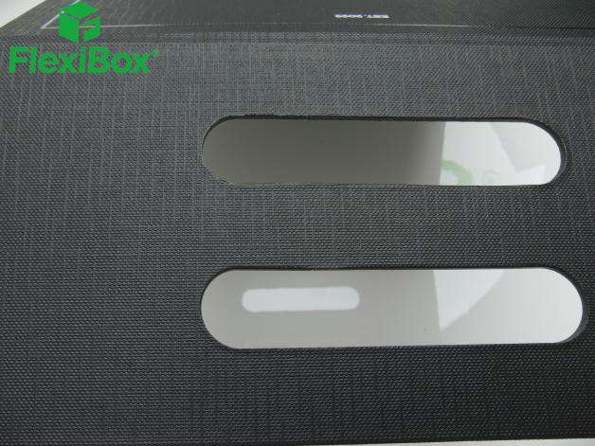

IV. Accessories Experience Features a built-in nylon webbing handle in the same color, die-cut and embedded, eliminating the need for an additional carrying bag; customers can directly carry the gift box when receiving it, providing complete outer packaging and reducing material consumption.

V. Style Positioning: South American/Latin American trendy dark minimalist style.

Without complex colors, it relies on texture, feel, and subtle patterns to create a cutting-edge street-style understated luxury, suitable for clothing, fragrance, and cultural and creative brands.

